# Misc:

## • APIs

* Query AWS endpoints to find info

## • Benefits of migrating to the AWS Cloud

* Doesn’t eliminate local computers, doesn’t reduce IT personal, doesn’t reduce development cost
* Reduces overall cost
* Eliminates need to guess capacity

## • AWS Cloud Adoption Framework (AWS CAF)

* Framework that Amazon makes detailing how you should run cloud. 6 perspectives. **Business. People. Governance. Platform. Security. Operations.**
* Business: focuses on growth, **business developments and business outcomes**
* People: Bridges tech and people. Focuses on **company culture, learning, cooperation** ect
* Governance: managing and running in a way to **maximizing benefits and minimizing risk**. Aligning business
* Platform: building a **scalable cloud interface**/platform, **modernizing workloads** ect
* Security: confidentiality, integrity and availability of data and workloads
* Operations: Delivering cloud services at the desired level, **day to day running**

## • AWS Compliance

* Framework that Amazon makes detailing how you should keep cloud secure

## • Compute

* AWS servers used for computing resources like AWS Lambda. usually referred when hosting applications or anything resource intensive on a computer.

## • Cost management

* Getting the most out of your services, optimizing return on spend.

## • Databases

Running SQL, No SQL, Oracle, etc. on any amazon storage service like s3

## • Amazon EC2 instance types (for example, Reserved, On-Demand, Spot)

* Reserved – Reserving a certain amount of space. You pay whether you use it or not but this can save up to 70% of your cost. cant go under 1 year.
* On-Demand – pay as you go, most expensive and you pay full cost. ALWAYS available.
* Spot-Instance – you save up to 90% of your cost. It is similar to a reserved instance but your instance will not always be up. This is used when a business does not need complete uptime on an EC2 instance. NOT always available, bidding occurs on unused instances.

## • AWS global infrastructure (for example, AWS Regions, Availability Zones)

* Availability zones – provide **FAULT TOLERENT = HIGHLY AVALIABLE**. Each availability zone has a completely separate source of resources so that a power outage at one datacenter will not affect another datacenter. Prevents datacenter failures on AWS’s part.
* Regions - Largest of the AWS Global infrastructures. Separate, large **geographical areas** which contain availability zones. **DIFFERENT PRICING, SERVICES!**
* Edge Location – provide **LOW LATENCY SERVICES**. Strategically positioned points in the AWS infrastructure which provides low latency to customers who are near that area.
* Pop/point of presence – provide **CACHE FOR YOUR CUSTOMERS.** Exists next to a very large population area like New York and pre-caches common data usages like a popular YouTube video to deliver low latency to users.

## • Infrastructure as code (IaC)

* Part of the well architected framework. Create all infrastructure as code so its easily scalable and elastic to change. Code is much easier to edit and change.

## • AWS Knowledge Center

- A webpage where common AWS Questions are answered.

## • Machine learning

- Refers to all AWS AI services such as AWS Polly and AWS Maria.

## • Management and governance

* AWS services that allow management and governance of users such as AWS Config or AWS CloudWatch. Auditing changes and access.

## • Migration and data transfer

* + Process of migrating on premise servers to the cloud and the process of transferring data to the cloud.
  + Migration: AWS Application migration service, AWS Database Migration service, Migration Hub
  + Transferring Data – Snow Family, Direct Connect, Storage Gateway.

## • AWS Partner Network

* + Paid subscription to join AWS Partner network. It provides teams of trained individuals to build solutions and services for customers. (DIFFERENT FROM SUPPORT PLANS). Allows co-selling services with AWS and offers discounts for partners.

## • AWS Prescriptive Guidance

* + Best practices for your business, guides, and patterns for accelerating **cloud migration** and optimizing projects. Developed by trained individuals.

## • AWS Pricing Calculator

* + Create cost estimates for services. Can get an estimate for how much an AWS service will cost for the rest of the month/year.

## • AWS Professional Services

* + A group of trailed professions that help a business determine business goals when using the AWS Cloud.

## • AWS re:Post

* literally a site like Stack overflow where people can make posts and shit about their problems and can get community help.

## • AWS SDKs

* AWS Software Defined Kits. Platform development tools for developers to use in AWS. Simplifies the usage of AWS services for developers that want to write code faster.

## • Security

## • AWS Security Blog

* A blog for posts relating to AWS security in the cloud and cloud configurations

## • AWS Security Center

Helps assess your network’s security. Assesses your AWS environment to security best practices.

## • AWS shared responsibility model

* The customer is responsible for security **in** the cloud. This means any software running on physical computers. Encrypting anything in the cloud is the customer’s responsibility and so is the physical data they put in. E.X security groups and managing the network of the cloud. AWS isnt responsible if you accidentally delete your cloud or give someone most permissions than they should have
* AWS is responsible for all security **of** the cloud. This means securing any hardware that runs the AWS servers, providing availability zones to give redundancy to databases and AWS services. Using any Software as a service or paas, or iaas, AWS is responsible for the underlying infrastructure. This means using Beanstalk, AWS is responsible for deploying applications using beanstalk whilst you are responsible for the data you put in.

## • AWS Solutions Architects

* An AWS certification. Helps businesses meet requirements by strategizing efficient ways of accomplishing that.

## • Storage

* EBS, S3, EFS, FSx, Elastic disaster recovery, Glacier, Snowfamily.

## • AWS Support Center

* A one-on-one talk with an AWS provided experienced technical support engineer. Pay by the month pricing and unlimited support cases.

## • AWS Support plans

* AWS free support tier: Access to resource center, service health dashboard, project FAQs, and discussion forums.
* Business: lowest paid tier. Usually recommended for businesses that dont wanna spend insane amounts of money on huge support plans. Trusted advisor checks will all be available for this and you can get 24/7 access to cloud experts with a less than 1 hour response time.
* AWS Enterprise on ramp: this is bootleg enterprise. Its not as good as enterprise and has all the same features just worse. 5 minute response times and you get access to AWS Managed services. AWS will probably say “your business doesnt want to pay for enterprise plan but want most of its features” then you click this option.
* Enterprise: hella expensive. You get 24x7 technical support from high-quality engineers, tools and technology to automatically manage health of your environment, consultative architectural guidance delivered in the context of your applications and use-cases, and a designated Technical Account Manager (TAM) to coordinate. Questions talking about enterprise usually talk about technical account manager.

## • AWS Well-Architected Framework

* 6 perspectives
* Operation Excellence
  + Perform all operations as code so the application is easily elastic and easy to change
  + Make Frequent, small changes so misconfigurations can easily be reverted.
  + refine operation procedures frequently so there is a set plan before making changes.
  + Anticipate failure
  + learn from failures
* security
  + Implement strong identity foundation.
  + Traceability for all access
  + apply security at all layers.
  + automate security best practices.
  + Protect data at rest and in transport
  + keep people away from data
  + prepare for security events.
* reliability
  + automatically recover from failure
  + test recovery procedures
  + scale horizontally (adding more machines or nodes) to increase workload availability.
  + stop guessing capacity
  + manage change in automation
* performance efficiency
  + democratize advanced technology (teach employees about how the cloud works)
  + go global in minutes
  + experiment more often
  + consider mechanical sympathy.
  + use a tool and understand how that tool operates at its best.
* cost efficiency
* sustainability

# Analytics:

## • Amazon Athena

* Query service for you to analyze S3 analytics and data using SQL queries
* Serverless, per query basis

## • AWS Data Exchange

* Private exchange of data between two organizations. Allows your own business to consolidate the data received from the other organization and receive the data using one API.

## • Amazon EMR

* Elastic Map Reduce. Simplifies running big data frameworks like Apache to process and analyze large amounts of data.

## • AWS Glue

* Serverless data integration service for users to discover, prepare, and move data from multiple sources into one. Can also do machine learning and application development similar to Lambda.
* **Extract, Transform, load** are the 3 words you need to know for glue.

## • Amazon Kinesis

* Serverless streaming data service that helps capturing and processing data to AWS for analytics. For machine learning, applications, playback.

## • Amazon Managed Streaming for Apache Kafka (Amazon MSK)

* Streamlines AWS Apache Kafka services. Any questions that mention Kafka will likely use Amazon MSK.

## • Amazon OpenSearch Service

* Streamlines the process of creating Opensearch clusters in AWS Cloud. Opensearch clusters allows ingesting, securing, aggregating, viewing, and analyzing data for cases like log analytics, enterprise search, and application search. Fully managed by AWS

## • Amazon QuickSight

* Business analytics. **Multiple users can see shared analytics of one report**. No upfront cost and serverless.

## • Amazon Redshift

* Analyzes structured data from a data warehouse or a database. Uses AWS hardware and machine learning to analyze specifically business standard SQL. Cheapest option to analyze SQL databases by far.

# Application Integration:

## • Amazon EventBridge

* Real time access to changes in AWS services and your own applications. If any AWS services were to unknowingly go down, Amazon Eventbridge is likely to be used to discover why that happened.

## • Amazon Simple Notification Service (Amazon SNS)

* Often time used with other AWS alarm services. If an Amazon EventBridge alarm or a CloudWatch alarm is triggered like when an application goes down or the company is about to go over its budget, the service will use SNS to send a message to the business.

## • Amazon Simple Queue Service (Amazon SQS)

* Provides **loose coupling meaning Asynchronous workloads.** This means that one device/application can easily scale up without at all effecting other devices connected to it.
* Processes messages in parallel with multiple SQS instances
* Scale microservices, distributed systems, and serverless applications.

## • AWS Step Functions

* Adds resilient workflow automation without writing code. Any workflows edited by AWS Step functions will automatically have error handling, parameter passing, and recommended security functions.

# Business Applications:

## • Amazon Connect

* AI powered cloud contact center. automatically detects customer issues and will provide agents to provide suggested responses and actions for faster resolution of their issues.

## • Amazon Simple Email Service (Amazon SES)

* literally sns but they send you an email instead of a notification. Can be attached to cloudwatch or budgets.

# Cloud Financial Management:

## • AWS Billing Conductor

* customizes pro-forma (a sheet of pre-calculated results using assumptions/presumptions on how your network is going to changa) version of your billing data for the end of the month. Can help configure a cost and usage report.

## • AWS Budgets

* Allows you to set a mandated budget for any resource. If your business is about to go over the budget, you can receive an Ses or Sns notification. BUDGETS CANNOT PAUSE YOUR INSTANCES. THEY WILL ONLY TELL YOU IF ITS ABOUT TO GO OVER BUDGET.

## • AWS Cost and Usage Report

* free AWS service. Shows your estimated costs associated with your account and can export that data to an S3 bucket. Uses the AWS Cost and Usage API to get these values and AWS Billing Conductor(billing conductor costs money after 2 months). Can aggregate information every hour, day, month. **You pay for AWS services every month,** so the Cost and Usage report generates monthly costs.

## • AWS Cost Explorer

* Costs a cent per request. allows customers to monitor their AWS costs. The difference between this and Cost and Usage report is that cost and usage report generates the total monthly cost that your services incur while cost explorer allows you to see a detailed report on how much each service costs. This means you can see the usage of all resources you used on AWS for the past 12 months. So Cost and usage report is for seeing current billing information whilst cost explorer lets you see past billing information and what it was spent on.

## • AWS Marketplace

* An online software store which your business can buy pre-created software's and services created by other AWS customers. (E.X machine images, software, containers). All services sold on AWS marketplace is secure and safe to use.

# Compute (6/3/2024 ryan):

## • AWS Batch

* Manages compute environment and **JOB QUEUE**
* Run a lot of jobs quickly

## • Amazon EC2

* Cloud computing provided by Amazon
* Highly scalable
* Containerization/virtualization of machines, Amazon provides the hardware and you provide the software to run
* Know Reserved, On-Demand, Spot instances
* Uses EBS for storage volumes of the machines

## • AWS Elastic Beanstalk

* Application management system, manages infrastructure and platform stuff
* Easy to deploy and scale applications without needing to manage infrastructure
* PaaS
* You provide the code, they provide the platform and it builds off of the other services (EC2, S3)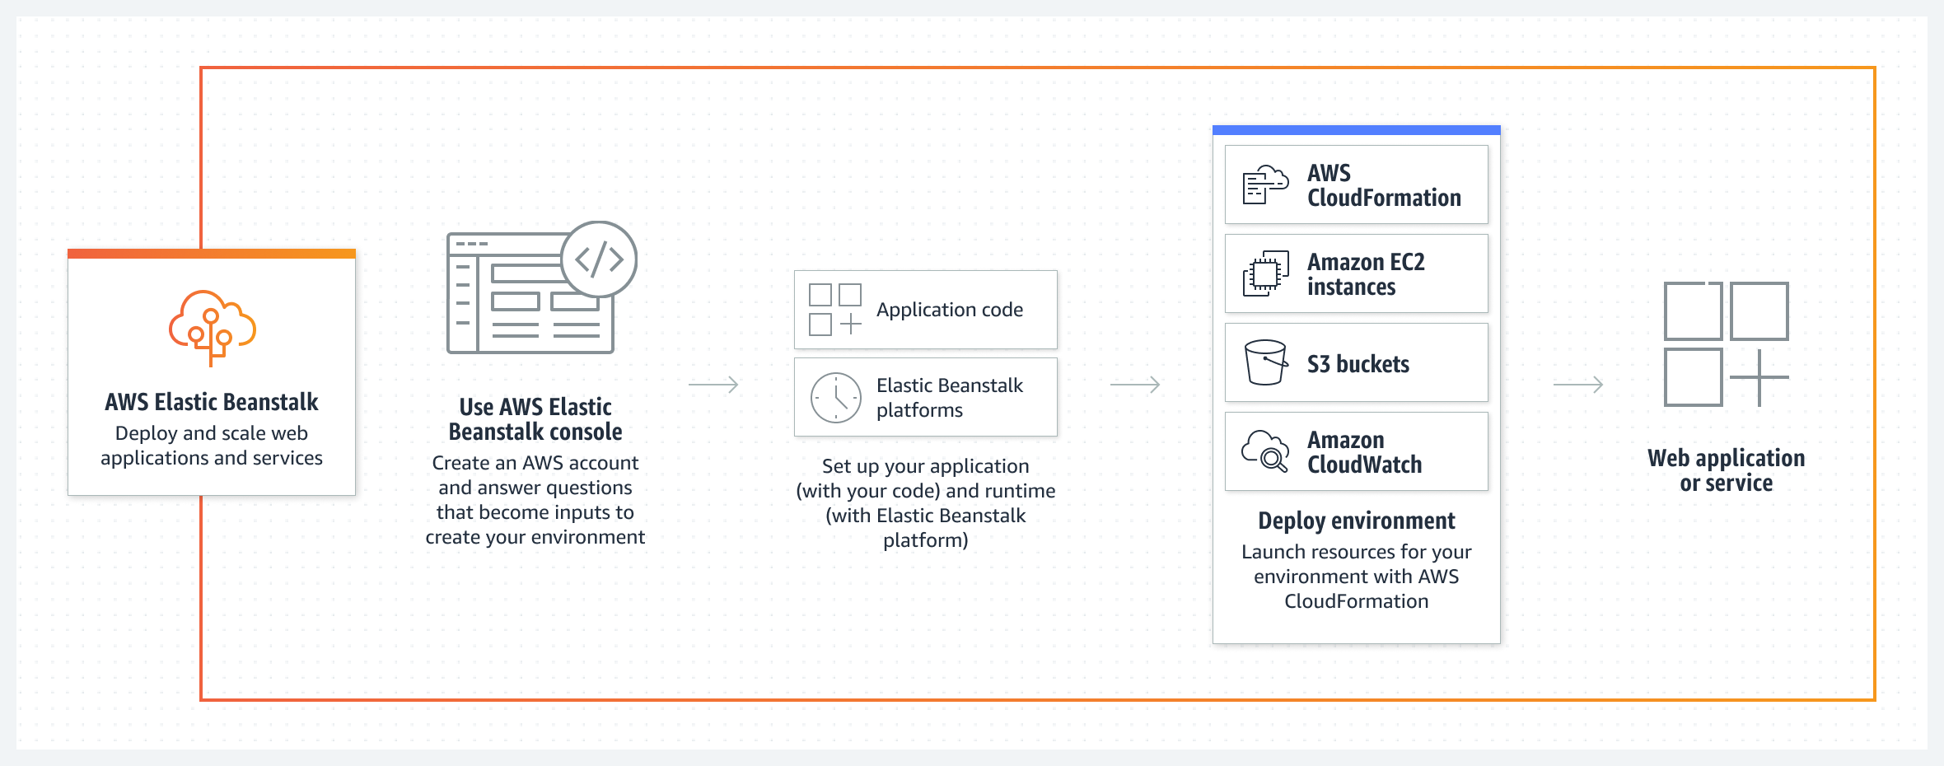

## • Amazon Lightsail

* Virtual Private Server (VPS), provides compute power, **REMEMBER, LIGHTSAIL = LIGHTWEIGHT APPLICATIONS**
* Similar to EC2 but for small scale applications (simple websites, small software, dev/test environments)

## • AWS Local Zones

* Infrastructure deployment that puts compute/storage/database close to large population places
* **REDUCE LATENCY** for end users

## • AWS Outposts

* AWS compute and storage capacity put at a physical customer site
* Deploying AWS software at YOUR own datacenter
* Basically you buy AWS equipment to run AWS software locally
* **REMEMBER, your data center becomes an OUTPOST of AWS**

## • AWS Wavelength

* **REDUCE LATENCY**
* Deploys AWS services (compute/storage) into 5G carrier networks, allowing for fast delivery

# Containers:

## • Amazon Elastic Container Registry (Amazon ECR)

* Stores code

## • Amazon Elastic Container Service (Amazon ECS)

* Lets you run and deploy

## • Amazon Elastic Kubernetes Service (Amazon EKS)

* kubernetes

# Customer Engagement:

## • AWS Activate for Startups

## • AWS IQ

* Help from AWS experts who can literally just do stuff for you in the AWS account
* AWS freelance basically

## • AWS Managed Services (AMS)

* Adopt AWS at a larger scale, operate more efficiently and securely

## • AWS Support

# Database:

## • Amazon Aurora

* uses MySQL and PostgreSQL. It is much more expensive than RDS but provides much more efficiency and performance. It is technically a part of RDS but cannot be deployed from RDS. Serverless Aurora exists if you want most of the benefits of Aurora which is more expensive but offers most of the benefits of using Aurora.

## • Amazon DynamoDB

* A NoSQL database key-value database. NoSQL means that DynamoDB has very high scalability, much more than relational databases. Very low latency with locating data. The main advantages it has over RDS is its performance and scalability. Downside of NOSQL databases: you lose flexibility (E.X difficult to create data graphs because everything is stored in keys)

## • Amazon MemoryDB for Redis

* A NoSQL database where speed is all that matters. Very high performance and saves up to 80% in costs. However, scalability is bad since it uses Redis which caches everything. Might take up a lot of performance with very large databases.

## • Amazon Neptune

* graph analytics to gleam insights over data in S3 buckets. Can quickly analyze large batches of data specifically in databases but only works in SQL databases.

## • Amazon RDS

* Relational Database Service. A fully managed service paas-like managed SQL database (meaning it cant use nosql). Lots of tools built in RDS which makes it paas. Advantages over DynamoDB is the added features and flexibility of the databases. Can auto-sort data, edit databases easily like creating indices. Its still extremely scalable but simply not as scalable as dynamo.

# Developer Tools:

## • AWS AppConfig

* Deploying configurations from a central location, a little bit like Ansible/Saltstack/Puppet/other
* Simplifying system adinistration

## • AWS CLI

* Manage AWS services, control them through scripts

## • AWS Cloud9

* Cloud-based IDE to write and run code
* Prepackaged languages/development environments to simplify workflow
* Allows for collaboration amongst multiple people

## • AWS CloudShell

* Browser based shell, run scripts in the cloud in combination with AWS CLI

## • AWS CodeArtifact

* Helps organizations store and share software packages for application development
* Repository service, pay for number of packages stored and number of requests made

## • AWS CodeBuild

* Build service in the cloud, compiles your code and runs tests on it
* Pay by build minutes, auto scales capacity to ensure speed

## • AWS CodeCommit

* Basically Git but by AWS
* Allow teams to collaborate on code without needing to worry about platform/infrastructure restritions

## • AWS CodeDeploy

* Automated code deployment to EC2, etc.
* Ability to roll back updates and keep track of deployment status, etc.

## • AWS CodePipeline

* CI/CD to automate releases for fast and reliable updates
* Mainly used for industry applications, to deploy updates and changes

## • AWS CodeStar

* Quickly build, develop, and deploy applications on AWS
* Templates to create projects quickly

## • AWS X-Ray

* Analyze and debug microservice applications
* Detailed view of how things travel through an application

# End User Computing:

## • Amazon AppStream 2.0

* provides users instant access to their desktop applications from anywhere in the world. Streams compute intensive applications to

## • Amazon WorkSpaces

* Make virtual workspaces (Windows, Linux, Ubuntu, etc.) for users

## • Amazon WorkSpaces Web

# Frontend Web and Mobile:

## • AWS Amplify

* Fully managed, deploy and host fullstack web applications

## • AWS AppSync

* API service for applications to access necessary data, combine multiple API’s into one

## • AWS Device Farm

* A “farm” of devices for testing your web app to see if it is compatible on different platforms
* For instance, Android, IOS, certain resolutions, etc.

# Internet of Things (IoT):

## • AWS IoT Core

## • AWS IoT Greengrass

# Machine Learning:

## • Amazon Comprehend

* Natural language processing

## • Amazon Kendra

* Intelligent search for employees to find information within repositories in your organization
* Integrated with LLMs and generative AI to create conversation like experiences

## • Amazon Lex

* Chatbot for users/customers
* Improves customer satisfaction

## • Amazon Polly

* Text to speech

## • Amazon Rekognition

* Pretrained computer vision models

## • Amazon SageMaker

* A set of tools to build and train ML models

## • Amazon Textract

* Automatically extracts text, formatting and other data from documents
* Handwriting to text ect

## • Amazon Transcribe

* Speech to text

## • Amazon Translate

* Translation duh

# Management and Governance:

## • AWS Auto Scaling

* Monitor and auto adjust resources for applications
* Optimize performance and cost
* Can be used for EC2, auto launch or terminate instances

## • AWS CloudFormation

* Model and manage infrastructure in an automated way, template and provision infrastructure basically

## • AWS CloudTrail

* Auditing user logs and activity
* Information about actions (who made the request, services used, permissions, parameters, etc.)

## • Amazon CloudWatch

* Logging of resource utilization and applications/infrastructure/network/services in general
* Use alarms and logs to take actions given certain issues

## • AWS Compute Optimizer

* Basically analyze CloudWatch/resource configuration and utilization and then provide recommendations
* Literally optimize your compute

## • AWS Config

* Record configuration changes to software in EC2 or VM’s
* Assess, audit, evaluate

## • AWS Control Tower

* Setup and manage a multi-account AWS environment
* Encourage best practices, control accounts

## • AWS Health Dashboard

* Source for events and changes that affect AWS cloud
* Service Dashboard = overall state of AWS services
* Personal Dashboard = overall state of personal AWS

## • AWS Launch Wizard

* Service to size and configure and deploy AWS resources for third party apps

## • AWS License Manager

* Managing licenses for software using AWS

## • AWS Management Console

* Control most of your AWS services from this console, broad overview of everything

## • AWS Organizations

* Control multiple AWS accounts in an organization under a central control
* Centralized IAM, security policy, auditing, control over accounts, etc.

## • AWS Resource Groups and Tag Editor

* Put tags or groups on something AWS related

## • AWS Service Catalog

* Automatically centrally manage cloud resources written in CloudFormation or other

## • AWS Systems Manager

* Configuration management to control your EC2 instances
* Add antivirus, firewall, other configuration stuff

## • AWS Trusted Advisor

* Online tool to help reduce cost and increase performance
* Provides real-time guidance
* Security, Cost Optimization, Resiliency, Fault-Tolerance, Service Limits)

## • AWS Well-Architected Tool

* Operational Excellence, Security, Reliability, Performance Efficiency, Cost Optimization, Sustainability
* Describes the 6 pillars of Jeff Bezos

# Migration and Transfer:

## • AWS Application Discovery Service

* Helps you find usage and configuration data about your on-premise servers and databases. Helps businesses plan migration to the cloud. Integrates discovery data with other migration services such as migration hub. Data from this service is encrypted in transit and at rest.

## • AWS Application Migration Service

* Recommended service to migrate to the cloud. Converts source servers and physical servers from physical/virtual to cloud infrastructure running on AWS.

## • AWS Database Migration Service (AWS DMS)

* Managed migration and replication service that helps move your database and analytics workload to aws quickly and securely with little downtime or data loss.

## • AWS Migration Hub

* Provides a hub for any ongoing migration services going on such as Application discovery service or migration service. Main purpose to help plan and track any services going on.

## • AWS Schema Conversion Tool (AWS SCT)

* Automatically converts any database schema from a physical/virtual server to a schema that is compatible with AWS RDS.

## • AWS Snow Family

* Mainly used for data migration from physical servers to the cloud. Since AWS direct connect or storage gateway are often extremely slow, AWS Snow Family is a service that will directly download the data from your physical servers onto a hard drive to the cloud.
* 3 tiers of snow family
* AWS Snowcone: around 8tb storage
* AWS Snowball: 50 tb storage
* Snowmobile: transfer up to 100petabytes of data.

## • AWS Transfer Family

* Transfer files in and out of AWS storage services

# Networking and Content Delivery (6/3/2024 ryan):

## • Amazon API Gateway

* AWS service for publishing API endpoints (GET, POST, etc.)

## • Amazon CloudFront

* **CDN,** delivers content to data centers (edge locations), **CACHE CONTENT**
* Uses **Point of Presence** to **reduce latency**
* Protect **DDOS**
* Cut costs
* Serverless

## • AWS Direct Connect

* Connect and send data to AWS resources **completely privately**
* Goes through AWS network instead of the internet
* Literally a physical connection to an AWS Direct Connect intermediary center, then to AWS

## • AWS Global Accelerator

* Improve network performance, high availability, failover, protect DDOS
* Provides two static IP’s as a fixed entry point

## • Amazon Route 53

* DNS delivery and routing
* **Reduce latency, increase availability**

## • Amazon VPC

* Virtual private cloud, dedicated to your AWS account
* A virtualized network that you can use to connect EC2 servers/other AWS services, runs fully in the cloud

## • AWS VPN

* Literally a VPN to connect to AWS or your own on-premise network
* Offers secure access to resources
* Autoscaling

# Security, Identity, and Compliance (6/3/2024 sunny):

## • AWS Artifact

* Artifact is a central resource for viewing compliance related reports
* On demand access to security and compliance reports from AWS and ISVs

## • AWS Audit Manager

* For auditing AWS usage and assessing risk/compliance
* Collects data from cloud trails and converts logs into more usable things
* Offers premade frameworks for common industry standards and regulations
* Allows you to build audit-ready reports with less manual work

## • AWS Certificate Manager (ACM)

* ACM provides a central place to manage SSL/TSL certificates
* Can be audited through cloudtrails logs

## • AWS CloudHSM

* AWS implementation of crypto HSM (hardware security modules)
* Basically, generate and use crypto keys through AWS compute
* Pay by the hour

## • Amazon Cognito

* Sign on users with AWS, used for authentication
* Mobile/web app sign on using AWS
* Provides temporary access to AWS resources

## • Amazon Detective

* Detect and find root cause of suspicious activity
* Automatically collects log data from AWS resources like EC2

## • AWS Directory Service

* Integration of Microsoft Active Directory with AWS
* Louie

## • AWS Firewall Manager

* Configure and manage firewalls using AWS
* Combined with AWS VPC to protect your networks

## • Amazon GuardDuty

* Uses ML to constantly monitor AWS resources and guard/detect attacks

## • AWS Identity and Access Management (IAM)

* Specify who gets what access to AWS resources
* Fine-grained permissions

## • AWS IAM Identity Center (AWS Single Sign-On)

* Assign your workspace users, manage who has access to what AWS resources
* Provide workspace with single sign-on

## • Amazon Inspector

* discovers any workloads like EC2 instances, ECS instances, and lambda functions and scans them for vulnerabilities such as software vulnerabilities or unintended network exposure

## • AWS Key Management Service (AWS KMS)

* centralizes control for cryptographic keys for all your services. Can create symmetric or asymmetric key encryption. The issue with this service is that anyone that has the credentials to access to the KMS service will have access to every key. There's no way to restrict specific keys from certain people or roles.
* Often integrated with other AWS services to make encryption easier.

## • Amazon Macie

* discovers sensitive data in only S3 buckets using machine learning and pattern matching. Finds security risks and enables automated protection from those risks. Often, Macie will only be used to discover if sensitive data was accidentally placed in the S3 buckets.

## • AWS Network Firewall

* stateful (meaning it stores all access/deny requests), managed ips and ids for a VPC that you create in amazon VPC. you can filter traffic only at the perimeter of the VPC. Difference between this and WAF is that Web Application Firewall only protects applications whilst this is for general use. operates on layer 3.

## • AWS Resource Access Manager (AWS RAM)

* Helps securely share resources across AWS accounts IAM roles for these resources. Can only be used within one AWS account. resources can be shared with individual AWS accounts.

## • AWS Secrets Manager

* helps protect access to applications, services, and resources. This is a secrets management service meaning its pretty much a password manager for credentials. Difference between this and KMS is that **Secrets manager auto rotates the keys.** Can store database credentials, application credentials, OAuth tokens, API keys, SSH keys, AWS credentials.

## • AWS Security Hub

* AWS Security Hub is a cloud security posture management (CSPM) service that performs automated, continuous security best practice checks against your AWS resources to help you identify misconfigurations and aggregates your security alerts. Whilst Guard duty focuses mostly on detection within specific AWS environments, Security Hub will provide a broader view of security and compliance across all your AWS accounts.

## • AWS Shield

* The only purpose of AWS shield is to prevent DDOS attacks on applications/instances. Stateless.

## • AWS WAF

* AWS web application firewall. Helps you configure rules that block/monitor network traffic. Protects against common exploits. main difference between this and the network firewall is that this operates on the application layer and thus only protects applications. Supports both stateful and stateless rules.

# Serverless:

## • AWS Fargate

* **SERVERLESS**, run **CONTAINERS** without managing servers
* **CONTAINERS!** Fargate is basically PaaS to the max, you just configure a few things
* Serverless version of ECS

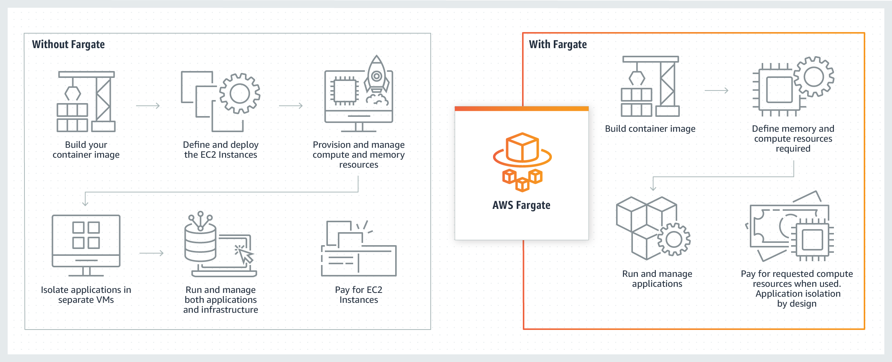

## • AWS Lambda

* **SERVERLESS,** same as Fargate but you run **CODE** instead of applications
* Only pay for the compute time you use
* Code by code basis
* Builds off of other AWS services

# Storage:

## • AWS Backup

* Provides interface to manage **DATA BACKUP**
* API, console, CLI to access the backups
* Used on other services like S3, FSx, EFS, EBS

## • Amazon Elastic Block Store (Amazon EBS)

* EBS creates virtual hard drives for VMs (EC2)
* VHDs are called EBS volumes
* All EBS volumes can be encrypted, but encryption might not be supported by EC2
* Data is stored on devices in a storage area network (SAN), not physically connected to any VMs
* Data is encrypted in transport
* EBS volumes can only be attached to one EC2 instance
* Can create snapshots of EBS instances. These are incremental backups meaning only data that has been changed is backed up. These snapshots can migrate data over regions making the EBS instance highly available.

## • Amazon Elastic File System (Amazon EFS)

* Serverless, elastic file storage
* Shared file system, can be used by many instances
* Linux only, basically **A NAS (Network Attacked Storage)**

## • AWS Elastic Disaster Recovery

* Provides point in time backups that can be quickly launched
* Data is replicated to a staging area subnet
* Reduces cost by using cheaper storage options and minimal computing resources
* Basically **VM SNAPSHOT**

## • Amazon FSx

* EFS for windows

## • Amazon S3

* Cloud object storage, used to store strictly FILES
* Pay for what you use

## • Amazon S3 Glacier

* Archive storage for **FILES**
* Instant retrieval **MOST EXPENSIVE**, Deep archive **LEAST EXPENSIVE**

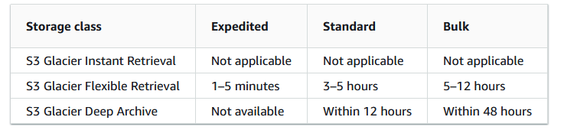

## • AWS Storage Gateway

* Hybrid cloud storage service
* Gives on premise devices access to cloud storage
* Data is transferred over the internet, physical drives do not move
* Low latency